**Family Project Data Analysis**

**BIO 199**

**By: Mildred Monsivais**

Table of Contents

Project Overview 4

Tools Used 4

Python Libraries Used 4

Goal 4

Data Process Flow Chart 5

Heatmap Flow Chart 5

PCA Flow Chart 5

Shannon H Flow Chart 6

Heatmaps 7

Level: All Families 7

0 Values in the Data 7

Level: Families 8

Level: Family 1 Individuals 9

Level: Family 2 Individuals 10

Level: Family 3 Individuals 11

Level: Family 4 Individuals 12

Principal Component Analysis 13

Why use PCA 13

What are we looking for in the PCA Charts 13

PCA Plot Interpretation 13

Level: All Families 13

Level: Families 14

Family 1 14

Family 2 14

Family 1 Values: k__Bacteria;p__TM7;c__TM7-3;o__;f__;g__ 14

Family 2 Values: k__Bacteria;p__TM7;c__TM7-3;o__;f__;g__ 14

Family 3 15

Family 4 15

Family 3 Values: k__Bacteria;p__Firmicutes;c__Bacilli;o__Lactobacillales;f__Streptococcaceae;g__Streptococcus 15

Family 4 Values: k__Bacteria;p__Firmicutes;c__Bacilli;o__Lactobacillales;f__Streptococcaceae;g__Streptococcus 15

Important Indexes Plot Based on PCA Outliers 16

Plotted Values 16

Shannon H Values 17

# **Project Overview**

## **Tools Used**

Python (Analysis)

Draw.io (Flow Charts)

Microsoft Word (Report)

## **Python Libraries Used**

1. pandas == 1.1.3
2. ecopy == 0.1.2.2
3. plotly.graph_objects == 4.13.0
4. scipy == 1.2.1

## **Goal**

To interpret the family data set by applying exploratory data analysis to summarize interesting features using Python in the dataset.

# **Data Process Flow Chart**

## **Heatmap Flow Chart**

## **PCA Flow Chart**

## **Shannon H Flow Chart**

# **Heatmaps**

## **Level: All Families**

## **0 Values in the Data**

In this heatmap we can see that there is a lot of values that are blue and on the color scale blue equates to 0 values. With this in mind, I counted how many individual values are 0’s and I found that 5576 out of 9504 values are 0. This is something that should be looked at because 58.67%(5576/99504) of the values in the data are 0’s. I believe this should be looked at more closely because this is something that is odd and could be an error with how the data was preprocessed.

## **Level: Families**

## **Level: Family 1 Individuals**

## **Level: Family 2 Individuals**

## **Level: Family 3 Individuals**

## **Level: Family 4 Individuals**

# **Principal Component Analysis**

**Why use PCA**  
I have 96 columns of data, and you can't visualize the interaction between the 96 variables at once. We can do this in pairs; however we will not see how all variables interact. Therefore, we will use PCA to reduce the 96 dimensions down to 2 dimensions of Principal Components measuring variability captured between the 2 components.

## **What are we looking for in the PCA Charts**

We are looking for any values that look like outliers. The outlier values that are away from the cluster of values (In this case names of the Taxon) in the PCA charts are the most important values, due to their distances. With this in mind, I decided to look at the outliers in each PCA graph and saw that the outlier values for the Family 1 chart is the same as the Family 2 chart. Also, the Family 3 chart and Family 4 chart have the same outlier values that I chose. These values are highlighted in the PCA charts.

## **PCA Plot Interpretation**

The values that are highlighted (with the ovals) in the following plots are considered outliers in the PCA plots, therefore these outliers mean that they of high significance. So I looked at the index(row) of these outliers and found that Family 1 and Family 2 have similarities with the k__Bacteria;p__TM7;c__TM7-3;o__;f__;g__ taxon and Family 3 and Family 4 have similarities with the k__Bacteria;p__Firmicutes;c__Bacilli;o__Lactobacillales;f__Streptococcaceae;g__Streptococcus taxon.

## **Level: All Families**

## **Level: Families**

## **Family 1**

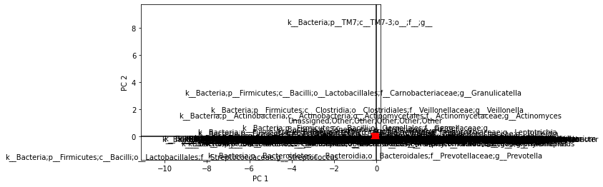

## **Family 2**

## **Family 1 Values: k__Bacteria;p__TM7;c__TM7-3;o__;f__;g__**



## **Family 2 Values: k__Bacteria;p__TM7;c__TM7-3;o__;f__;g__**



## **Family 3**

## **Family 4**

## **Family 3 Values: k__Bacteria;p__Firmicutes;c__Bacilli;o__Lactobacillales;f__Streptococcaceae;g__Streptococcus**



## **Family 4 Values: k__Bacteria;p__Firmicutes;c__Bacilli;o__Lactobacillales;f__Streptococcaceae;g__Streptococcus**



## **Important Indexes Plot Based on PCA Outliers**

## **Plotted Values**

Family 1 PCA Outlier (k__Bacteria;p__TM7;c__TM7-3;o__;f__;g__)

Family 2 PCA Outlier (k__Bacteria;p__TM7;c__TM7-3;o__;f__;g__)

Family 3 (k__Bacteria;p__Firmicutes;c__Bacilli;o__Lactobacillales;f__Streptococcaceae;g__Streptococcus)

Family 4 (k__Bacteria;p__Firmicutes;c__Bacilli;o__Lactobacillales;f__Streptococcaceae;g__Streptococcus)

Again, these values are the outliers we found in the PCA plots above. As we can see, the values between Family 1and Family 2 are very close and the values between Family 3 and Family 4 are very close.

# **Shannon H Values**

|  |  |
| --- | --- |
| **Category** | **Value** |
| D Alpha | 5.945649222183524 |
| D Beta | 1.3877187447376873 |
| D Gamma | 8.250888875259127 |